Some of the State of Michigan’s Symbols
by
Alex Soper and Riley-Grossman-Lempert

Michigan State Flower: Apple Blossom
The apple blossom (Pyrus coronaria), native to Michigan, was deemed the state flower in 1897. The flower was chosen because it was known to be both extremely fragrant and beautiful. Also, Michigan was well known for its apples and ranks third in the US for apple production. These trees are grown both to be used commercially and for decorative purposes. The blossoms are known as crabapples. The typical apple blossom blooming season is between April and June. In Michigan, these trees are most frequently grown along the shores of Lake Michigan. They thrive in the climate of that area. The apple tree is tall, growing upwards of 20 to 40 feet tall. Petals on apple blossom flowers can range anywhere from white or pink to a red color. They appear in clusters and have five petals, which produce a strong, sweet scent, similar to honeysuckle. The smell attracts lots of bees that pollinate, and because of this, crabapples are commonly used on farms to pollinate other apple trees. Crabapples are not appetizing to eat; however, they are frequently used in the making of jellies and other preservatives.

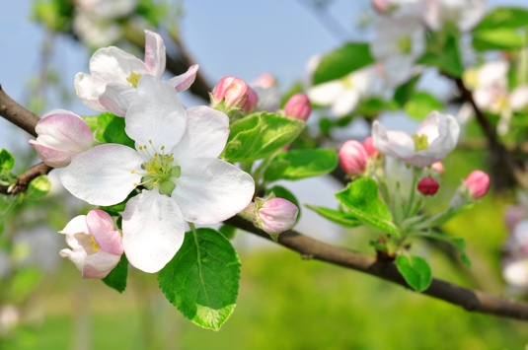
Credit: Floraqueen.com

Michigan State Fish: Brook Trout
The Brook Trout (Salvelinus fontinalis) was selected as the state fish of Michigan in 1988. It took more than twenty years for legislators to designate which species of trout was the state fish. Up until then, the state fish was just the Trout, selected in 1965. These fish are native to Michigan. Brook trout must live in clean, cold, water. This makes Michigan a perfect place for them to live because we have plenty of fresh water in our streams, rivers, and lakes. Brook trout are commonly found in Upper Peninsula streams as well as in lakes in the northern portion of the Lower Peninsula. They are also found in abundance in the Au Sable and Manistee rivers. Brook trout are relatively small fish. On average, the largest they are found to be is 6.5 pounds and are around 10 to 12 inches in length. On another note, these fish have an eye-catching look, with many colors. Their fins are bright and orange with black trim all around them. Their base body color can be anything from green to black and has colored red or gold spots. The male fish have red on their bellies.

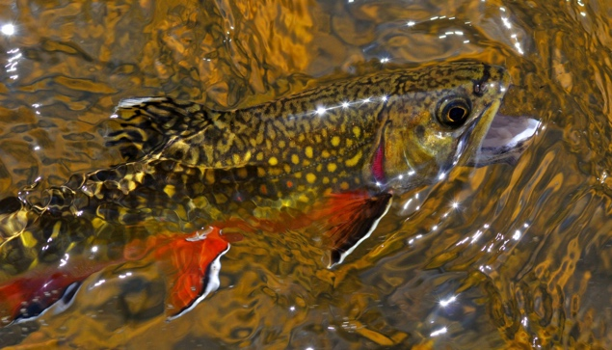
Credit: Fishingbooker.com

Michigan State Gem: Isle Royale Greenstone
Michigan’s state gem was recognized in 1973, the Isle Royale Greenstone. The mineral name for the Isle Royale Greenstone is Chlorastrolite which means “green star stone” in Greek. This stone is found predominately in the Upper Peninsula and Isle Royale. Unfortunately, they are illegal to be collected at Isle Royale due to the fact it is a national park. However, this stone is also found in the Keweenaw Peninsula at its copper waste rock piles and along some Lake Superior beaches. There they are allowed to be collected. When found in Keweenaw, they are often embedded into basalt. At Isle Royale you would likely find them as small pebbles or stones on a beach. While not true, this fact causes many to think the greenstone on Isle Royale is superior. As far as the look of the stone, it is a blue, green, almost turquoise color, some are a darker color, and some are lighter. The stone has a “turtleback” pattern and is a round shape. In Michigan, the stone is sometimes referred to as “turtleback.” Chlorastrolite stones are commonly used to make jewelry since they have a good hardness of 5 – 6. The jewelry made can include necklaces, earrings, or even rings.

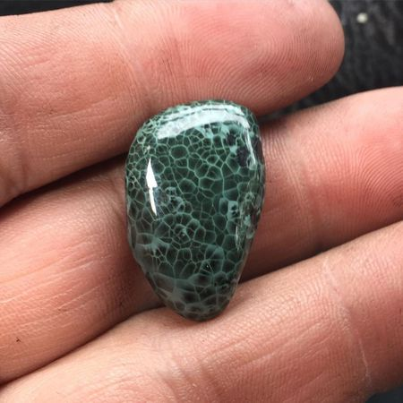
Credit: Mlive.com

Michigan State Song: “My Michigan”
“My Michigan” became the official state song on May 21, 1937. This song is often confused with the song “Michigan, My Michigan,” another song about the state and very popularly believed to be the state song. This is the case because “My Michigan” has never been released into the public domain. Thus, it has rarely ever been sung or played, causing no one to know it. Due to this fact, it is next to impossible to find the lyrics of the song anywhere. The rights to the song were never bought by the state and as of now, there is no plan to buy them. After refusal to buy the rights, the song was changed to “an official” state song. A bill in 2003 failed to pass which would have made “Michigan, My Michigan” the official state song. “My Michigan” was written four years before it was adopted in 1993. The lyrics were written by Giles Kavanagh and the music was written by O’Reilly Clint. The official sheet music is currently located in two places in the state, the Bentley Historical Museum at the University of Michigan, and the Library of Michigan in Lansing.

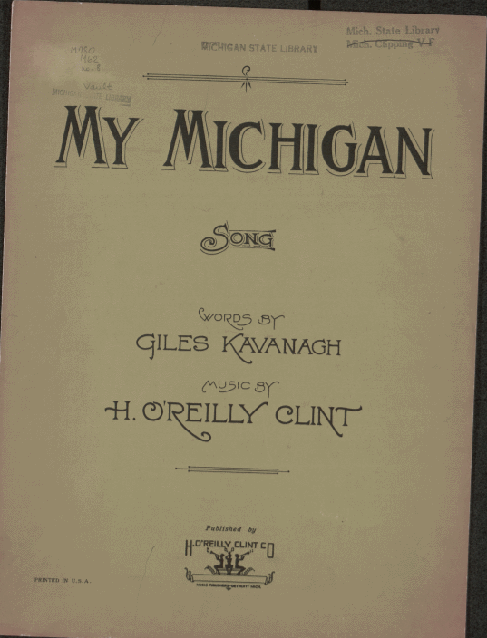
Credit: Wiikipedia.com
Michigan State Tree: Eastern White Pine
The eastern white pine (Pinus strobus), or soft pine, was deemed Michigan’s state tree in 1955. The tree was selected because it pays homage to the rich history of logging in the state. The state’s lumber boom took place from the 1870s to the early 1900s. At the time Michigan was the number one state for lumber production, pine playing a large factor. The eastern white pine is native to Michigan. It has multiple uses, including flooring, furniture, medicinal purposes, and even Christmas trees. These trees live for about 200 to 250 years. As far as appearance the tree is one of the tallest in North America, sometimes growing upwards of 200 feet tall. The leaves of the tree are its pine needles, which appear in bundles of five and range anywhere from 2 to 5 inches long. The pine needles contain large amounts of Vitamin C, which is why this tree is utilized for medicine making. The flower of the tree is its pinecones. These are around 4 to 7 inches long and are cylindrical in shape. The Native American Iroquois Confederation deemed this tree the “Tree of Peace.”

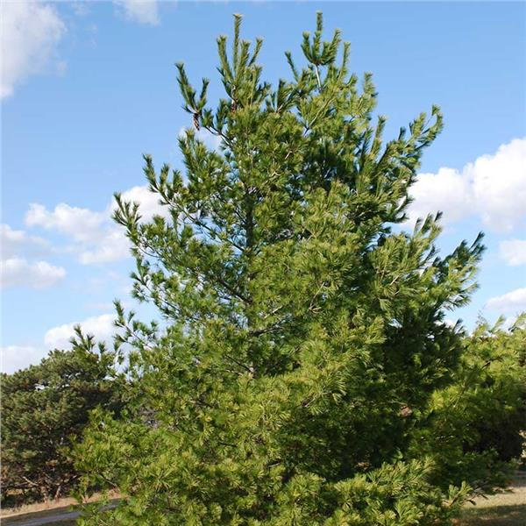
Credit: Arborday.org
Michigan State Bird: American Robin
The state bird of Michigan is the American robin (Turdus migratorius) or robin redbreast. The robin was selected in 1931. According to state legislation the robin is significant because “the robin redbreast is the best known and best loved of all the birds in the state of Michigan” (“Why the rockin’ robin,” 2015). The chickadee was the state’s second choice. The robin is found all over North America and is the nation’s most abundant bird. Robins are known as songbirds, and their chirps are a sign of spring. They sing first thing in the morning. Robins like to escape the cold winter. This is when they move to their warmer climates. Robins are about ten inches long. They are mostly all gray. However, their underparts are orange. During mating season, the males grow black feathers on their heads. Robins eat seeds, berries, or even worms. Robins are known to be in their flocks or in groups at night. During the day they are active and mostly on their own. Robins live in grassy lawns or in nests in trees or sheltered areas. They are known to be preyed upon by predators such as hawks, cats or snakes. They are very protective of each other and are always watching out for predators.

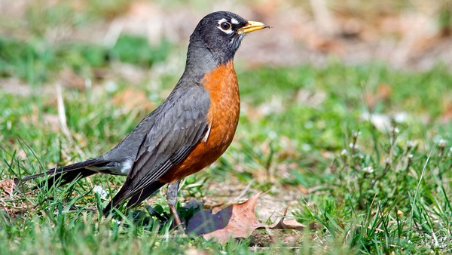
Credit: National Audubon Society

Michigan State Reptile: Painted Turtle
In 1995, fifth-graders from Niles, Michigan realized that Michigan did not have a state reptile. Later that year, the Michigan legislature made their nomination official - Michigan’s state reptile would be and still is the painted turtle.
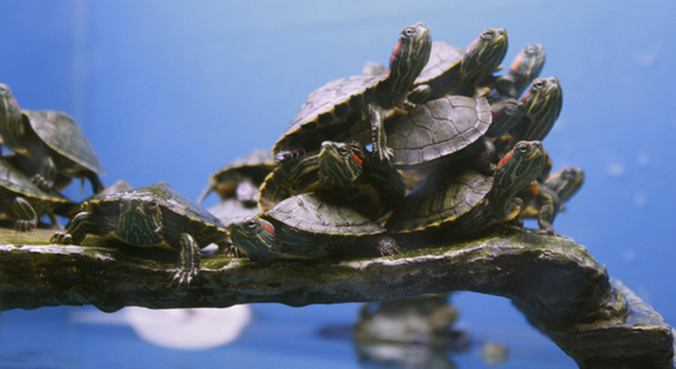
Source: unknown

Identification and Subspecies
Scientifically named Chrysemys picta, the painted turtle is the most common turtle in Michigan and can be found all across the United States, with the only notable exception being the southwestern states. Growing to a full size of about four to seven inches in length, female painted turtles are usually larger and have shorter front claws than their male counterparts. Not known for their size but their coloration, the painted turtle has yellow stripes on its head and both red and yellow stripes on its neck, legs, and tail. The top of the painted turtle’s shell - its carapace - is often a black or olive color, and red markings run along the edge of the carapace and between the sections or scutes of the carapace, as well as under the scutes along the edge of the carapace. The underbelly - the bottom of their shell, also known as the lower shell or plastron - is usually yellow with an occasional red tint with a dark pattern stretching lengthwise down from its front to its back. The exact shape of this blotch is what helps determine the difference between the various subspecies of painted turtle.

Of the four subspecies of painted turtle, only two are found in Michigan. The western painted turtle (Chrysemys picta belli) is found only in the Upper Peninsula, with only the easternmost edge of the peninsula not being home to them. The midland painted turtle (Chrysemys picta marginata), in contrast, is found throughout the Lower Peninsula as well as most of the Upper Peninsula, being found in the entire eastern side and reaching as far west as Iron and Baraga Counties. This means for the central part of the Upper Peninsula, both kinds of painted turtle in Michigan can be found. As mentioned above, the way to tell the difference between the subspecies is to look at the dark shape on their plastron. The midland painted turtle has a pattern holding a more solid shape similar to a pickle or a corn cob if it is even visible, whereas the western painted turtle has a pattern that looks more undefined, ‘bleeding’ up the seams between the scutes on their lower shell. This can prove more difficult than it sounds, as these subspecies breed without issue and thus most painted turtles found in the Upper Peninsula are some intermediate between the two. In 1977 a pair of scientists studied the painted turtle across the Upper Peninsula and their study only found pure western painted turtles in Ontonagon and Houghton Counties and pure midland painted turtles in Chippewa and Luce Counties. This does not mean that there are not purebred painted turtles of either subspecies in the other counties of the Upper Peninsula, merely that they did not find any in their study.

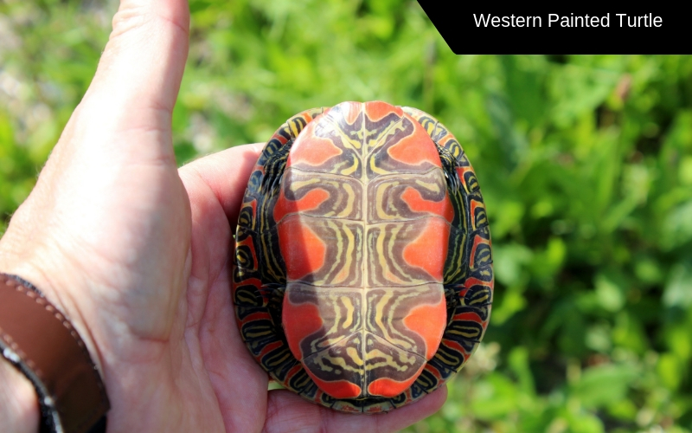
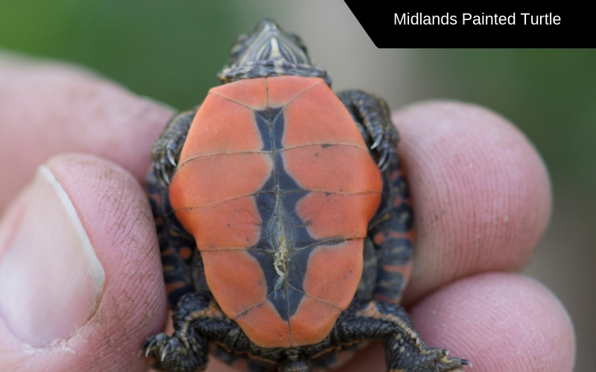

Source: Western painted turtle - modfos via 123RF Stock Photo
Source: Midland painted turtle - lakephotography via 123RF Stock Photo

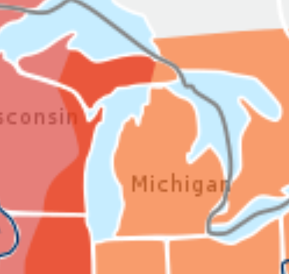
Source: Cropped Wikipedia map - Orange is where the midland painted turtle can be found, pink is where the western painted turtle can be found, red stands for locations both can be found

Habitat, Food, and Predators
While the painted turtle prefers shallow water with lots of aquatic vegetation and a muddy bottom, they can make their home in a variety of bodies of water. They have been known to live in ponds, lakes, marshes, and even slow-flowing streams and rivers and are willing to make the journey on land to find a place to call home. They do require something to bask in the sun upon, although this can be logs, lily pads, thick vegetation, or even trash. They can survive in more urban environments and can even handle organic pollution. They are not overly picky eaters either - they eat aquatic plants, insects, snails, crayfish, tadpoles, small fish, and carrion.

Painted turtles have about as wide a list of predators as they do of food - known predators include squirrels, rats, muskrats, chipmunks, minks, woodchucks, skunks, badgers, cats, foxes, raccoons, fish crows, bullfrogs, snapping turtles, various snakes, large fish, heron, osprey, alligators, bald eagles, red-shouldered hawks, and humans.

Reproduction and Hibernation
The painted turtle’s mating season is often the spring but has been noted to take place at any time they are not hibernating, with females nesting from late May into July. These nesting sites are sunny and near the water, with moist sand or soil. Anywhere from four to twenty eggs are laid, although the number is most commonly around seven or eight, and then carefully covered. These eggs are elliptical in shape and are noted as having soft shells. The eggs hatch after about seventy to eighty days, and either get to the water or remain buried until the following spring. Hatchling painted turtles are about an inch long and can survive with over half of the fluids in their bodies frozen into ice.

Painted turtles as a whole are incredibly well-equipped for handling the winter. They can survive underwater all winter without breathing, having one of the greatest tolerances for lack of oxygen of any vertebrate. They hibernate either digging into or resting on the bottom of their habitat, hibernating from around October to early April.

Works Cited
“American Robin.” Audubon, 14 Apr. 2020, www.audubon.org/field-guide/bird/american-robin.
“American Robin.” Wikipedia, Wikimedia Foundation, 15 Apr. 2021, en.wikipedia.org/wiki/American_robin.
“Apple Blossom.” State Symbols USA, statesymbolsusa.org/symbol-official-item/michigan/state-
flower/apple-blossom.
Bingham, Emily. “Why Michigan's Gorgeous State Gemstone Is so Rare.” Mlive, 20 Apr. 2018, www.mlive.com/entertainment/erry-2018/04/64a09f0d318324/isle_royale_greenstone.html.
“Brook Trout.” State Symbols USA, statesymbolsusa.org/symbol-official-item/michigan/state-fish-aquatic-life/brook-trout.
“Cayuse Canyon, LLC.” The US50 - A Guide to the Fifty States, www.theus50.com/michigan/bird.php.
“Chlorastrolite.” Wikipedia, Wikimedia Foundation, 21 Oct. 2020, en.wikipedia.org/wiki/Chlorastrolite.
“Eastern White PinePinus Strobus.” Eastern White Pine Tree on the Tree Guide at Arborday.org, www.arborday.org/trees/treeguide/treedetail.cfm?itemID=903.
“Five Facts About Michigan Greenstones.” Beth Millner Jewelry, www.bethmillner.com/blogs/jewelry-business-blog/5-greatest-facts-about-greenstones.
Flora Queen . www.floraqueen.com/blog/apple-blossom-michigan-state-flower-fragranced-beauty.
“Greenstone Facts.” Keweenaw Gem and Gift, copperconnection.com/pages/greenstone-facts.
“List of Michigan State Symbols.” Wikipedia, Wikimedia Foundation, 22 Jan. 2021, en.wikipedia.org/wiki/List_of_Michigan_state_symbols.
“Michigan Official Song.” Michigan Official Song: My Michigan, www.ereferencedesk.com/resources/state-song/michigan.html.
“Michigan State Fish: A Feisty Charmer!” FishingBooker Blog, FishingBooker Blog, 12 Mar. 2021, fishingbooker.com/blog/michigan-state-fish-a-feisty-charmer/.
“Michigan State Flower - The Apple Blossom.” ProFlowers Blog, 16 Jan. 2017, www.proflowers.com/blog/michigan-state-flower-the-apple-blossom/.
“Michigan State Reptile.” Michigan State Reptile: Painted Turtle (Chysemys Picta), www.ereferencedesk.com/resources/state-symbols/michigan/reptile.html.
“Michigan State Tree.” Michigan State Tree: Eastern White Pine (Pinaceae Pinus Strobus), www.ereferencedesk.com/resources/state-tree/michigan.html.
“My Michigan.” Wikipedia, Wikimedia Foundation, 1 Jan. 2021, en.wikipedia.org/wiki/My_Michigan.
“Painted Turtle.” State Symbols USA, statesymbolsusa.org/symbol-official-item/michigan/state-reptile/painted-turtle.
“Pinus Strobus.” Wikipedia, Wikimedia Foundation, 13 Apr. 2021, en.wikipedia.org/wiki/Pinus_strobus.
“Robin Redbreast.” State Symbols USA, statesymbolsusa.org/symbol-official-item/michigan/state-bird/robin-redbreast.
Schouw, Paul Vander. “Painted Turtle Care Sheet.” Reptiles Magazine, 3 June 2020, www.reptilesmagazine.com/painted-turtle-care-sheet/.
“Why the Rockin' Robin Is Michigan's State Bird.” Detroit Free Press, Detroit Free Press, 8 Apr. 2015, www.freep.com/story/news/2015/04/08/michigan-history-state-bird/25422807/.

